|  |  |
| --- | --- |
|  |  |

*XYZ* System

Use Case Specification

Group/Team: *XYZ*

TABLE OF CONTENTS

USE CASE DIAGRAM(s) 3

STRIDE ANALYSIS 4

UC1 Name of use case 5

Basic Flow of Events 5

Alternative Flows 5

A1 – Brief title / label here 5

A2 – Brief title / label here 5

UC2 Name of use case 6

Basic Flow of Events 6

Alternative Flows 6

A1 – Brief title / label here 6

A2 – Brief title / label here 6

UC3 Etc… 7

*Remove this paragraph after reading. The table of contents above will be automatically generated from various section headings throughout the document below. Remember to update this table before you submit your document, to ensure that it reflects the most up to date content you have added. You can do this by right-clicking on the table and selecting ‘Update Field’.*

USE CASE DIAGRAM(s)

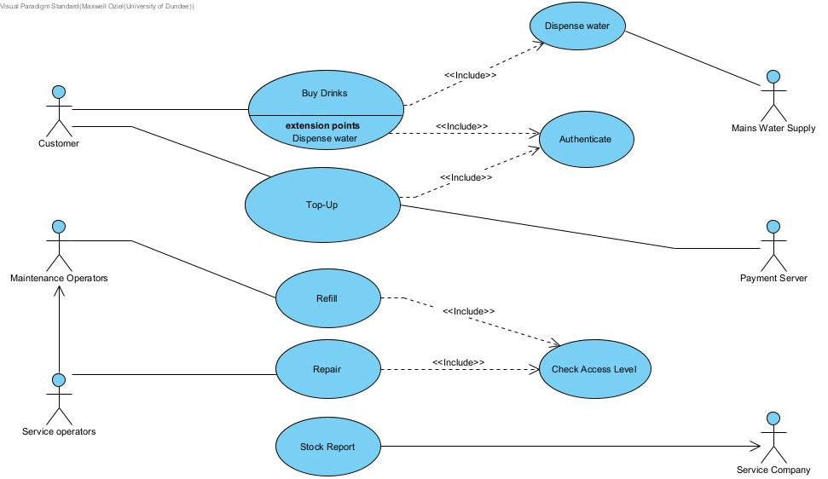

STRIDE ANALYSIS

**Spoofing**: The vending machine could be vulnerable to spoofing attacks, where an attacker impersonates a legitimate user or vending machine service operator or maintenance operator to gain unauthorized access to the machine or to steal drinks.

**Tampering**: The vending machine could also be vulnerable to tampering, where an attacker physically alters the machine to gain unauthorized access or to steal drinks. For example, an attacker could try to break into the machine to steal the drink or damage the card reader slot to make it easier to steal drinks.

**Repudiation**: There is a risk that a user could repudiate a transaction or deny that they made a purchase from the vending machine. For example, a user could claim that the machine did not dispense the correct drink.

**Information Disclosure:** The vending machine could be vulnerable to information disclosure attacks, where an attacker could gain access to sensitive information such as the inventory levels or sales data. For example, an attacker could use a network scanner to intercept and steal sensitive data being transmitted between the machine and the central server.

**Denial of Service:** A denial of service attack could be launched against the vending machine, either by physically damaging the machine or by flooding the machine with requests in an attempt to overload it and prevent legitimate users from accessing it.

**Elevation of Privilege:** There is a risk that an attacker could elevate their privileges on the vending machine to gain unauthorized access or control. For example, an attacker could exploit a vulnerability in the software running on the machine to gain service operator or maintenance access and modify the inventory or card top up settings.

UC1: BUY DRINK

Basic Flow of Events

|  |  |
| --- | --- |
| Customer: | The use case begins when the customer wants to buy drink and insert vending card |
| System: | Machine will read the card. (**A1**) |
| System: | The system will display the amount of credit in the vending card |
| Customer: | The customer will see available balance. |
| System: | The system will display the available drinks ready for purchase. |
| Customer: | Then customer choose their desirable drink(**A2**)(**A3**) |
| System: | The system ask the customer the desired temperature for their chosen drink cold or hot |
| Customer: | The customer chooses their desired temperature for the drink. |
| System: | The system dispense the choice of the customer and deduct the amount from the customer’s vending account. |
| Customer: | The customer takes the dispensed drink. |
| System: | The system return to the starting screen and display the remaining balance of the customer’s vending card |
| Customer: | The customer choose to buy more or ends the transaction and eject their card. |
|  |  |

Alternative Flows

A1 – Cannot read Vending Card

|  |  |
| --- | --- |
| System: | The system gives an error message of invalid card |
| Customer: | The customer check and clean the vending card and insert it properly. |
| System: | The system approve the card and allow the customer to choose the drink. |

A2 – Authentication failed

|  |  |
| --- | --- |
| System: | The system will require the customer to enter the correct pin |
| Customer: | The customer enter the correct pin. |
| System: | The system approve the pin and display the balance and the available drink to the customer. |

A3 – Low credit

|  |  |
| --- | --- |
| System: | Display low credit and ask the customer to top Up. |
| Customer: | Proceed to top up the vending card. |

UC2: TOP UP

Basic Flow of Events

|  |  |
| --- | --- |
| Customer: | The customer initiate the use case by inserting their vending card into the machine. |
| System: | The machine will authorize the card for transaction.(A1) |
| Customer: | To top up, the customer enters their bank credit card information. |
| System : | The system sends the customers bank details to the payment server for verification. |
| Payment server : | The payment server process the request and complete the transaction by toping up the customer’s vending card with £30 maximum.(A2) |
| System : | The system then display a successful top up to their account. |

Alternative Flows

A1 – card authentication failed.

|  |  |
| --- | --- |
| Customer : | Enter the correct pin. |
| System: | They system approve and continue the process. |

A2 – Declined transaction

|  |  |
| --- | --- |
| Payment server: | The payment server send error message to the vending machine. |
| System: | The system displays the error message to the customer. |
| Customer: | Enter the correct bank details. |
| System : | The system sends the customers bank details to the payment server for verification. |
| Payment server: | Approves the transaction. |

UC3: Dispense Water

Basic Flow of Events

|  |  |
| --- | --- |
| Main water supply : | The main water supply supplies water to the vending machine. (A1) |
| System : | Half of the water will be heated by the system, leaving the other water cold. |
| Customer: | The customer choose to buy drink or take water for free. |
| System: | The system display option of either cold or hot. |
| Customer: | The customer select his desired option. |
| system : | Dispense the water as selected. |

Alternative Flows

A1 – No water from the main water supply

|  |  |
| --- | --- |
| Main water supply: | The main water supply is empty. |
| System: | The system would halt the purchase of drink and free water dispensing. |

UC4: Refill

Basic Flow of Events

|  |  |
| --- | --- |
| Maintenance Operator | The use case is initialized by the maintenance operator inserting a special card into the machine. |
| System | The system read the special card inserted by the maintenance operator. |
| Maintenance operator | The maintainer enters the authorization pin to login. |
| System | The system check the pin. **E1: Invalid Pin** |
| System | The system access the operational level of the card inserted to make sure it has access level one (1) and unlock the door. |
| Maintenance Operator | The Maintenance Operator get access to the interior of the vending machine. |
| Maintenance Operator | Check available stock and refill stock |
| Maintenance Operator | Clean the machine |

Alternative Flows

A1 –

Exception Flow

E1: Invalid pin

|  |  |
| --- | --- |
| System | The pin is invalid |
| System | The system will not give access to the maintainer |
| System | The system will prompt the operator to re-enter pin. |